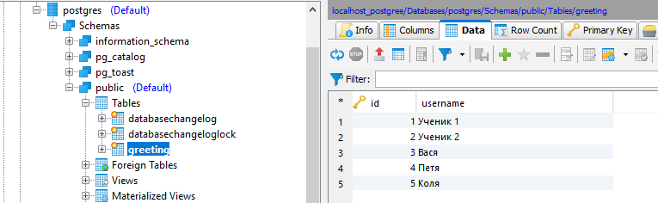

2021-04-11 11:29:14.144 INFO 36744 --- [ main] r.l.s.RestServiceApplicationTests : Started RestServiceApplicationTests in 8.84 seconds (JVM running for 10.186)

2021-04-11 11:29:14.254 INFO 36744 --- [ main] ru.leo.springDemo.log.LoggingAspect : Вызван метод createGreeting параметры: {bodyParams={id=28, content=LeoTiger}}

2021-04-11 11:29:14.323 INFO 36744 --- [ main] ru.leo.springDemo.log.LoggingAspect : Результат: {"id":6,"user":"LeoTiger","content":"Здравствуй, ученик, LeoTiger!"}

2021-04-11 11:29:14.323 INFO 36744 --- [ main] ru.leo.springDemo.log.LoggingAspect : Вызван метод updateGreeting параметры: {bodyParams={id=28, content=LeoTiger28}, id=6}

2021-04-11 11:29:14.365 INFO 36744 --- [ main] ru.leo.springDemo.log.LoggingAspect : Результат: {"id":6,"user":"LeoTiger28","content":"Здравствуй, ученик, LeoTiger28!"}

2021-04-11 11:29:14.366 INFO 36744 --- [ main] ru.leo.springDemo.log.LoggingAspect : Вызван метод greeting параметры: {id=6}

2021-04-11 11:29:14.369 INFO 36744 --- [ main] ru.leo.springDemo.log.LoggingAspect : Результат: {"id":6,"user":"LeoTiger28","content":"Здравствуй, ученик, LeoTiger28!"}

2021-04-11 11:29:14.369 INFO 36744 --- [ main] ru.leo.springDemo.log.LoggingAspect : Вызван метод greetings параметры: {}

2021-04-11 11:29:14.530 INFO 36744 --- [ main] ru.leo.springDemo.log.LoggingAspect : Результат: [{"id":1,"user":"Ученик 1","content":"Здравствуй, ученик, Ученик 1!"},{"id":2,"user":"Ученик 2","content":"Здравствуй, ученик, Ученик 2!"},{"id":3,"user":"Вася","content":"Здравствуй, ученик, Вася!"},{"id":4,"user":"Петя","content":"Здравствуй, ученик, Петя!"},{"id":5,"user":"Коля","content":"Здравствуй, ученик, Коля!"},{"id":6,"user":"LeoTiger28","content":"Здравствуй, ученик, LeoTiger28!"}]

2021-04-11 11:29:14.530 INFO 36744 --- [ main] ru.leo.springDemo.log.LoggingAspect : Вызван метод deleteGreeting параметры: {id=6}

2021-04-11 11:29:14.541 INFO 36744 --- [ main] ru.leo.springDemo.log.LoggingAspect : Результат: null

2021-04-11 11:29:14.541 INFO 36744 --- [ main] ru.leo.springDemo.log.LoggingAspect : Вызван метод greetings параметры: {}

2021-04-11 11:29:14.543 INFO 36744 --- [ main] ru.leo.springDemo.log.LoggingAspect : Результат: [{"id":1,"user":"Ученик 1","content":"Здравствуй, ученик, Ученик 1!"},{"id":2,"user":"Ученик 2","content":"Здравствуй, ученик, Ученик 2!"},{"id":3,"user":"Вася","content":"Здравствуй, ученик, Вася!"},{"id":4,"user":"Петя","content":"Здравствуй, ученик, Петя!"},{"id":5,"user":"Коля","content":"Здравствуй, ученик, Коля!"}]

2021-04-11 11:29:14.561 INFO 36744 --- [extShutdownHook] o.s.s.concurrent.ThreadPoolTaskExecutor : Shutting down ExecutorService 'applicationTaskExecutor'

2021-04-11 11:29:14.562 INFO 36744 --- [extShutdownHook] j.LocalContainerEntityManagerFactoryBean : Closing JPA EntityManagerFactory for persistence unit 'default'

2021-04-11 11:29:14.564 INFO 36744 --- [extShutdownHook] com.zaxxer.hikari.HikariDataSource : HikariPool-1 - Shutdown initiated...

2021-04-11 11:29:14.567 INFO 36744 --- [extShutdownHook] com.zaxxer.hikari.HikariDataSource : HikariPool-1 - Shutdown completed.